ACKNOWLEDGEMENT

I would like to express my sincere gratitude to all those who have supported me throughout the completion of this project.
First and foremost, I extend my heartfelt thanks to Dr. Anuradha M. Naik, Principal, Shivaji Arts, Commerce and BCA College, Baad, Karwar, for providing the necessary facilities and support throughout the course of my studies.
It gives me immense pleasure to express my deep appreciation to Mrs. Smita Savant, Head of the Department (HOD), for her encouragement and support.I am especially thankful to my project guide, Mr. Mohit Naik, for his constant guidance, valuable suggestions, and motivation throughout the duration of this project. His support was instrumental in the successful completion of this work.I also wish to thank all the faculty members and staff of the department for their cooperation and encouragement during this journey.
Finally, I am truly grateful to my family and friends for their continuous moral support, inspiration, and encouragement at every stage.This project has been a valuable learning experience, and I am sincerely thankful to everyone who helped and supported me throughout.

SUTEJ S NAIK
BCA Final Semester

TITLE OF THE PROJECT
PET HAVEN

Contents
- Introduction
- Objectives
- System Analysis
- Existing system
- Proposed System
- Feasibility Study
- Technical
- Economical
- Operational
- Hardware and Software Requirements
- Software requirement Specification
- HTML
- CSS
- PHP
- MY SQL
- JavaScript
- Source Code Overview
- System Design
- Use Case Diagram
- Dataflow Diagram
- Entity Relationship Diagram
- Database Design
- Database Table
- Database Schema
- Interface Design
- Validation
- Testing
- Limitations
- Future scope of the project
- Conclusion
- Bibliography
INTRODUCTION

Pets bring love, joy, and companionship into people’s lives, but unfortunately, many pets end up abandoned or in need of a new home. Pet Haven is a web-based pet adoption platform designed to bridge the gap between pet owners looking to rehome their pets and individuals looking to adopt. The platform provides a structured and user-friendly system where pet owners can list their pets for adoption, and potential adopters can browse available pets and submit adoption requests.
Pet Haven simplifies the adoption process by offering a centralized system where users can create accounts, manage pet listings, and track adoption requests. Once an adoption request is submitted, pet owners can review applications and directly connect with adopters to finalize the adoption. The website ensures that all necessary details, such as pet descriptions, images, owner contact information, and adoption statuses, are transparently displayed for users.
This project aims to promote responsible pet adoption by providing an efficient, well-organized, and easy-to-use platform. By streamlining the adoption process, Pet Haven helps pets find loving homes while offering pet seekers a hassle-free way to adopt.

OBJECTIVES

- To create an easy-to-use platform for pet adoption - Helping pet owners find new homes for their pets and allowing adopters to browse and adopt pets conveniently.

- To implement secure user registration and login - Ensuring that only registered users can submit pets for adoption and apply for adoption.

- To enable direct communication between pet owners and adopters - Displaying the user’s contact details to pet owners after they submit an adoption request.

- To allow users to manage Pet efficiently – connecting owners who want to give their pets a new home with people who are looking to adopt, through a simple and organized online platform.

EXISTING SYSTEM

- Lack of a centralized platform – People have to search multiple sources to find adoptable pets.

- Limited communication – No streamlined way for pet owners and adopters to interact.

- Manual record-keeping – Adoption requests are often managed informally, leading to confusion.

- Unverified adopters – Owners have no structured way to evaluate adoption applications.

- Difficulty in updating pet status – Once a pet is adopted, there is no clear system to update availability.

PROPOSED SYSTEM

- User Authentication – Ensures only registered users can list or apply for pets.

- Organized Pet Listings – Pets are displayed with necessary details and image.

- Adoption Request Management – Pet owners receive and manage adoption requests efficiently.

- Direct Contact Information – Owners can access Adopters details immediately upon applying.

- Admin Panel – Allows administrators to monitor and manage pet listings, adoption requests, and user messages.

FEASIBILITY STUDY

The feasibility study for Pet Haven evaluates the practicality and viability of the proposed pet adoption website. It assesses whether the system can be developed and operated successfully within the constraints of available technology, budget, and user needs. The purpose is to clearly define the problem scope and determine the key aspects to be included in the system. The result of this study is a formal proposal to proceed with development.

Technical Feasibility:
- Development tools like XAMPP, PHP, MySQL, HTML, and CSS are open-source and compatible with most systems.
- No special hardware or advanced software is required.
- Basic technical skills in web development are sufficient for implementation.
Economic Feasibility:
- All development tools used (XAMPP, VS Code, etc.) are free and open-source.
- No cost is incurred for domain or hosting during development since it is deployed on localhost.
Operational Feasibility:
- The system is user-friendly with a clean interface, allowing users to use the website without complications..
- Even users with minimal technical knowledge can operate the website easily.
HARDWARE REQUIREMENTS

- Processor: Intel i3 or higher / AMD Ryzen 3 or higher
- RAM: Minimum 4GB (8GB recommended for better performance)
- Storage: Minimum 20GB free space (SSD preferred)

Software Requirements

- Operating System: Windows 10/11, Linux (Ubuntu), or macOS
- Web Server: XAMPP (Apache, MySQL, PHP)
- Database: MySQL
- Backend Language: PHP
- Frontend Technologies: HTML5,CSS3,JavaScript
- Code Editor: Visual Studio Code

Software requirement specification

HTML
(Hyper Text Markup Language)

Hyper Text Markup Language Is A Basis Of Creating Web Page. The Internet Is Latest Technology Of Exchanging Information. Even The Corporate Sector Is Investing A Large Amount Of Money Is Creating Web Site And Making Their Presence Felt. Hypertext Markup Language Was Envisioned To Be Format For Allowing People Using Different Computers To Share Information Seamlessly Over The Network. These Sectors Were Essential For the Formulation Viz. Platform Independence. Hypertext and Semantic Structure
A Markup Language Such As Hypertext Markup Language Is Simple A Collection Of Codes Called Elements Which Are Used To Indicate The Structure And Often The Format Of A Document. A Web Browser That Renders The Document Interprets The Meaning Of These Codes To Figure Out How To Structure Or Display A Document. Hypertext Markup Language Is Language Used To Write Hypermedia Documents For The World Wide Web (Www). Hypertext Markup Language Is A Subset Of Generalized Markup Language. It Is Similar To A Computer Programming Language, It Has Commands Called Tags And Syntax Rules To Be Observed When Writing In Hypertext Markup Language.

CSS
(Cascading Style Sheet)

It’s a style sheet language used for describing the look and formatting of a document written in a markup language while most often the used to change the style of web pages and user interfaces written in HTML and XHTML, CSS is a corner stone technology used by most websites to create visually engaging Web pages, user interfaces application, and user interfaces for many mobile application.
CSS is designed primarily to enable the separation of documents content from documents presentation, including element such as the layout, colors and fonts. This separation can improve content accessibility and provide more flexibility and control in the specification of presentation characteristics, enable multiple pages (HTML) to share formatting be specifying the relevant CSS in a separate CSS file, and reduce complexity and repetition in the structural content, such as semantically insignificant tables that were widely used to format pages before consistent CSS rendering was available in all major browsers.
This separation of formatting and content makes it possible to present the same markup page in different styles for different rendering methods

JAVASCRIPT

Java script is a programing language commonly used in web development. It was originally developed by Netscape as a means to dynamic and interactive elements to websites. While java script is influences java, the syntax is more similar to C and is based on ECMA a script language developed by sun Microsystems.
Java Script is client-side scripting language, which means to code processed by the client’s web browser rather than on the web server example a java Script function may check a web form before is submit make sure all the required fields out. The java Script produce an error message before information is to the server.
Like server-side scripting language, such as PHP ASP code can be interested anywhere within the HTML a webpage. The output of server-side code is displayed in the HTML while java remains fully visible in the source of webpage.

PHP
(Hypertext Preprocessor)

PHP is a popular open-source server-side scripting language designed specifically for web development. It is embedded within HTML to execute server-side logic, allowing web pages to be generated dynamically based on user inputs, database queries, or other processing requirements. PHP scripts run on the web server, which processes client requests and sends back the generated HTML for display in the user's browser.
PHP's syntax is similar to C and Perl, making it easy to learn for developers familiar with these languages. It is widely supported across hosting providers and integrates seamlessly with databases like MySQL, making it a common choice for database-driven websites and web applications.
One of PHP's strengths is its ability to handle form data, manage sessions, cookies, and file uploads, as well as connect to databases to create, read, update, and delete data. It supports object-oriented programming and procedural programming styles, providing flexibility for different project requirements.
PHP also has a rich ecosystem of frameworks (such as Laravel and CodeIgniter) and content management systems (such as WordPress and Drupal) that speed up development. Its community support and extensive documentation contribute to its longevity and popularity.

MySQL

MySQL is an open-source relational database management system (RDBMS) that uses Structured Query Language (SQL) to manage and organize data efficiently. As one of the most popular databases in web development, MySQL stores data in tables consisting of rows and columns, where relationships can be established between tables to ensure data consistency and reduce redundancy.
MySQL supports a wide range of data types and provides features like indexing, transactions, views, and stored procedures to improve performance and reliability. It allows multiple users and applications to access and manipulate data concurrently while maintaining integrity through locking and transactional controls.Its client-server architecture enables the database server to respond to queries from remote clients, facilitating scalable and distributed applications. MySQL is often paired with server-side languages like PHP to create dynamic, data-driven websites.Security features in MySQL include user authentication, data encryption, and access control mechanisms that restrict data access based on user roles and privileges. Additionally, MySQL supports backups and replication to ensure data durability and availability.The ease of installation, extensive community support, and compatibility with many platforms have made MySQL a cornerstone technology in web application development.

Source Code Overview

index.php
<?php
session_start();
include 'includes/config.php'; ?>

<!DOCTYPE html>
<html lang="en">
<head>
<link href="https://fonts.googleapis.com/css2?family=MuseoModerno&display=swap" rel="stylesheet">
<meta charset="UTF-8" />
<meta name="viewport" content="width=device-width, initial-scale=1.0">
<title>Pet Haven - Home</title>
<link rel="stylesheet" href="assets/css/style.css">
<script src="assets/js/script.js"></script>

<link href="https://unpkg.com/aos@2.3.1/dist/aos.css" rel="stylesheet">
<style>
html {
scroll-behavior: smooth;
}
.btn:hover {
box-shadow: 0 0 15px #00f0ff;
transform: scale(1.05);
transition: 0.3s ease;
}
.pet-card {
transition: transform 0.3s ease, box-shadow 0.3s ease;
}
.pet-card:hover {
transform: translateY(-5px);
box-shadow: 0 0 20px rgba(0, 240, 255, 0.3);
}
</style>
</head>
<body>

<!-- Header / Navbar -->
<header>
<div class="logo"> Pet Haven</div>
<ul class="nav-links">
<li><a href="abt.php">About us |</a></li>
<li><a href="pets/pets.php">Adopt |</a></li>
<li><a href="pets/submit_pet.php">Submit Pet |</a></li>
<li><a href="contact.php">Contact |</a></li>
<li>
<?php if (isset($_SESSION['user_id']) && !empty($_SESSION['user_id'])): ?>
<a href="users/profile.php" class="btn">Profile</a>
<?php else: ?>
<a href="users/login.php" class="btn">Login</a>
<?php endif; ?>
</li>
</ul>
</ul>
</header>

<!-- Hero Section -->
<section class="hero" data-aos="fade-up">

<h1>Find Your New Best Friend! </h1>
<p>Adopt, don’t shop! Give a loving pet a new home.</p>
<a href="pets/pets.php" class="btn">Browse Pets</a>
</section>

<!-- How Adoption Works Section -->
<section class="how-adopt" data-aos="fade-up">

<div class="content-box">
<h2> How Adoption Works? </h2>
<ul>
<li><u><strong>Browse Pets:</strong></u> Look through the available pets and find the perfect match. </li>
<li><u><strong>View Details:</strong></u> Click on a pet to see more information about the pet. </li>
<li><u><strong>Adoption Process:</strong></u> Owner will directly contact you after you have submitted the adoption form </li>
<li><u><strong>Adopt & Update:</strong></u> Once adopted, the owner marks the pet as adopted, and the pet is removed from the listings.</li>
</ul>
<p>It's that simple! Give a pet a forever home today. </p>
</div>
</section>

<!-- Main Content -->
<div class="container" data-aos="fade-up">

<h2>Why Adopt from Pet Haven? </h2>
<p>Every pet deserves a loving home. Adopting a pet means saving a life .</p>

<!-- Featured Pets Section -->
<div class="featured-pets" data-aos="fade-up">
<h2>Meet Our Featured Pets! </h2>
<div class="pet-container">
<?php
$query = "SELECT * FROM pets WHERE status='Available' ORDER BY RAND() LIMIT 3";
$result = mysqli_query($conn, $query);
while ($row = mysqli_fetch_assoc($result)) {
$formattedDate = date("M j, Y", strtotime($row['date_posted']));

echo '<div class="pet-card">
<img src="assets/images/' . $row['image'] . '" alt="Pet">
<h3>' . $row['name'] . '</h3>
<p><strong>' . $row['breed'] . ' | ' . $row['age'] . ' </strong></p>
<h4>Submitted on: <strong>' . $formattedDate . '</strong></h4>
<a href="pets/pet_details.php?id=' . $row['id'] . '" class="btn">View Details</a>
</div>';
}
?>
</div>
</div>
</div>
<!-- Place for adoption section -->
<div class="put-for-adoption-section" data-aos="fade-up">
<div class="put-adoption-steps">
<h2>Put Your Pet Up for Adoption</h2>
<ul>
<li>Step 1: Fill out the pet details</li>
<li>Step 2: Upload pet images</li>
<li>Step 3: Submit your pet for adoption</li>
<li>Step 4: Wait for adoption requests</li>
</ul>
<a href="pets/submit_pet.php" class="put-adoption-btn">Submit Your Pet</a>
</div>
</div>
<!-- Footer -->
<?php include 'includes/footer.php'; ?>
<!-- AOS Script -->
<script src="https://unpkg.com/aos@2.3.1/dist/aos.js"></script>
<script>
AOS.init({
duration: 1000,
once: true
});
</script>
</body>
</html>

admin.php
<?php
session_start();
include '../includes/config.php';

// Check if admin is logged in
if (!isset($_SESSION['user_id']) || $_SESSION['is_admin'] != 1) {
header("Location: ../users/login.php");
exit();
}

// Fetch counts for dashboard
$pets_count = $conn->query("SELECT COUNT(*) AS count FROM pets")->fetch_assoc()['count'];
$adoptions_count = $conn->query("SELECT COUNT(*) AS count FROM adoptions WHERE status='Approved'")->fetch_assoc()['count'];
$pending_adoptions = $conn->query("SELECT COUNT(*) AS count FROM adoptions WHERE status='Pending'")->fetch_assoc()['count'];
$messages_count = $conn->query("SELECT COUNT(*) AS count FROM contact_messages")->fetch_assoc()['count'];
?>

<!DOCTYPE html>
<html lang="en">
<head>
<meta charset="UTF-8">
<title>Admin Dashboard</title>
<link rel="stylesheet" href="../assets/css/adminn.css">
</head>
<body>
<header>
<div class="logo">Pet Haven Admin</div>
<ul class="nav-links">
<li><a href="../users/logout.php" class="btn">Logout</a></li>
</ul>
</header>

<div class="container">
<h2>Admin Dashboard</h2>
<div class="dashboard">
<div class="box">
<h3>Total Pets</h3>
<p><?php echo $pets_count; ?></p>
</div>
<div class="box">
<h3>Total Adoptions</h3>
<p><?php echo $adoptions_count; ?></p>
</div>
<div class="box">
<h3>Pending Adoptions</h3>
<p><?php echo $pending_adoptions; ?></p>
</div>
<div class="box">
<h3>Messages</h3>
<p><?php echo $messages_count; ?></p>
</div>
</div>
<div class="links">
<a href="manage_pets.php" class="btn">Manage Pets</a>
<a href="manage_adoptions.php" class="btn">Manage Adoptions</a>
<a href="messages.php" class="btn">View Messages</a>
</div>
</div>
<!-- Footer -->
<footer><p>© 2025 Pet Haven. All rights reserved by <strong>SUTEJ NAIK</strong>. </p>
</footer>
</body>
</html>

pets.php

<?php
session_start();
include '../includes/config.php';

// Fetch all available pets
$pets_result = $conn->query("SELECT * FROM pets WHERE status = 'Available'");
?>

<!DOCTYPE html>
<html lang="en">
<head>
<link href="https://fonts.googleapis.com/css2?family=MuseoModerno&display=swap" rel="stylesheet">
<meta charset="UTF-8">
<title>Available Pets</title>
<link rel="stylesheet" href="../assets/css/pets.css">

<!-- AOS Animation Library -->
<link href="https://unpkg.com/aos@2.3.1/dist/aos.css" rel="stylesheet">
<style>
html {
scroll-behavior: smooth;
}

.pet-card {
transition: transform 0.3s ease, box-shadow 0.3s ease;
border-radius: 12px;
overflow: hidden;
}

.pet-card:hover {
transform: scale(1.05);
box-shadow: 0 0 15px #00f0ff, 0 0 5px #39FF14;
}

.pet-card img {
transition: transform 0.3s ease;
}

.pet-card:hover img {
transform: scale(1.05);
}

.pet-card:hover {
border: 2px solid #00f0ff;
}

</style>
</head>
<body>

<!-- Header / Navbar -->
<header>
<div class="logo"> Pet Haven</div>
<ul class="nav-links">
<li><a href="/pet_haven_/index.php">Home |</a></li>
<li><a href="/pet_haven_/abt.php">About Us |</a></li>
<li><a href="/pet_haven_/pets/submit_pet.php">Submit Pet |</a></li>
<li><a href="/pet_haven_/contact.php">Contact |</a></li>
<li>
<?php if (isset($_SESSION['user_id']) && !empty($_SESSION['user_id'])): ?>
<a href="/pet_haven_/users/profile.php" class="btn">Profile</a>
<?php else: ?>
<a href="/pet_haven_/users/login.php" class="btn">Login</a>
<?php endif; ?>
</li>
</ul>
</header>

<!-- Title Section -->
<div class="title-container" data-aos="fade-down">
<h2>Available Pets for Adoption </h2>
<p>Find a loving companion and give them a forever home! </p>
</div>

<!-- Featured Pets Section -->
<div class="featured-pets" data-aos="fade-up">
<div class="pet-container">
<?php while ($pet = $pets_result->fetch_assoc()): ?>
<div class="pet-card" data-aos="zoom-in">
<img src="../assets/images/<?php echo htmlspecialchars($pet['image']); ?>" alt="Pet Image">
<h4><?php echo htmlspecialchars($pet['name']); ?></h4>
<p><?php echo htmlspecialchars($pet['breed']); ?> | <?php echo htmlspecialchars($pet['age']); ?></p>
<p><?php echo htmlspecialchars($pet['gender']); ?></p>
<p><strong>Submitted on:</strong> <?php echo date("F j, Y", strtotime($pet['date_posted'])); ?></p>
<a href="pet_details.php?id=<?php echo $pet['id']; ?>" class="btn">View Details</a>
</div>
<?php endwhile; ?>
</div>
</div>

<?php include '../includes/footer.php'; ?>

<!-- AOS JS -->
<script src="https://unpkg.com/aos@2.3.1/dist/aos.js"></script>
<script>
AOS.init({
duration: 1000,
once: true
});
</script>

</body>
</html>

Use case diagram
(admin)
Login

Dashboard Overview

View All Submitted Pets

Change Pet Status

Delete Pets

View All Adoption Request
Approve/Reject Adoption Request

View Contact Messages

Use case diagram
(users)
Register
Login

Edit Profile

View Pets

Apply for Adoption

Submit Pet for Adoption
View My Adoption

Manage Submitted Pets

View Adoption Requests

Approve/Reject Request (owner)

Data flow diagram
(users)

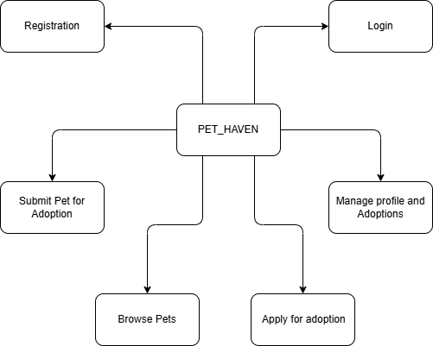

CONTEXT LEVEL DFD (LEVEL ZERO)

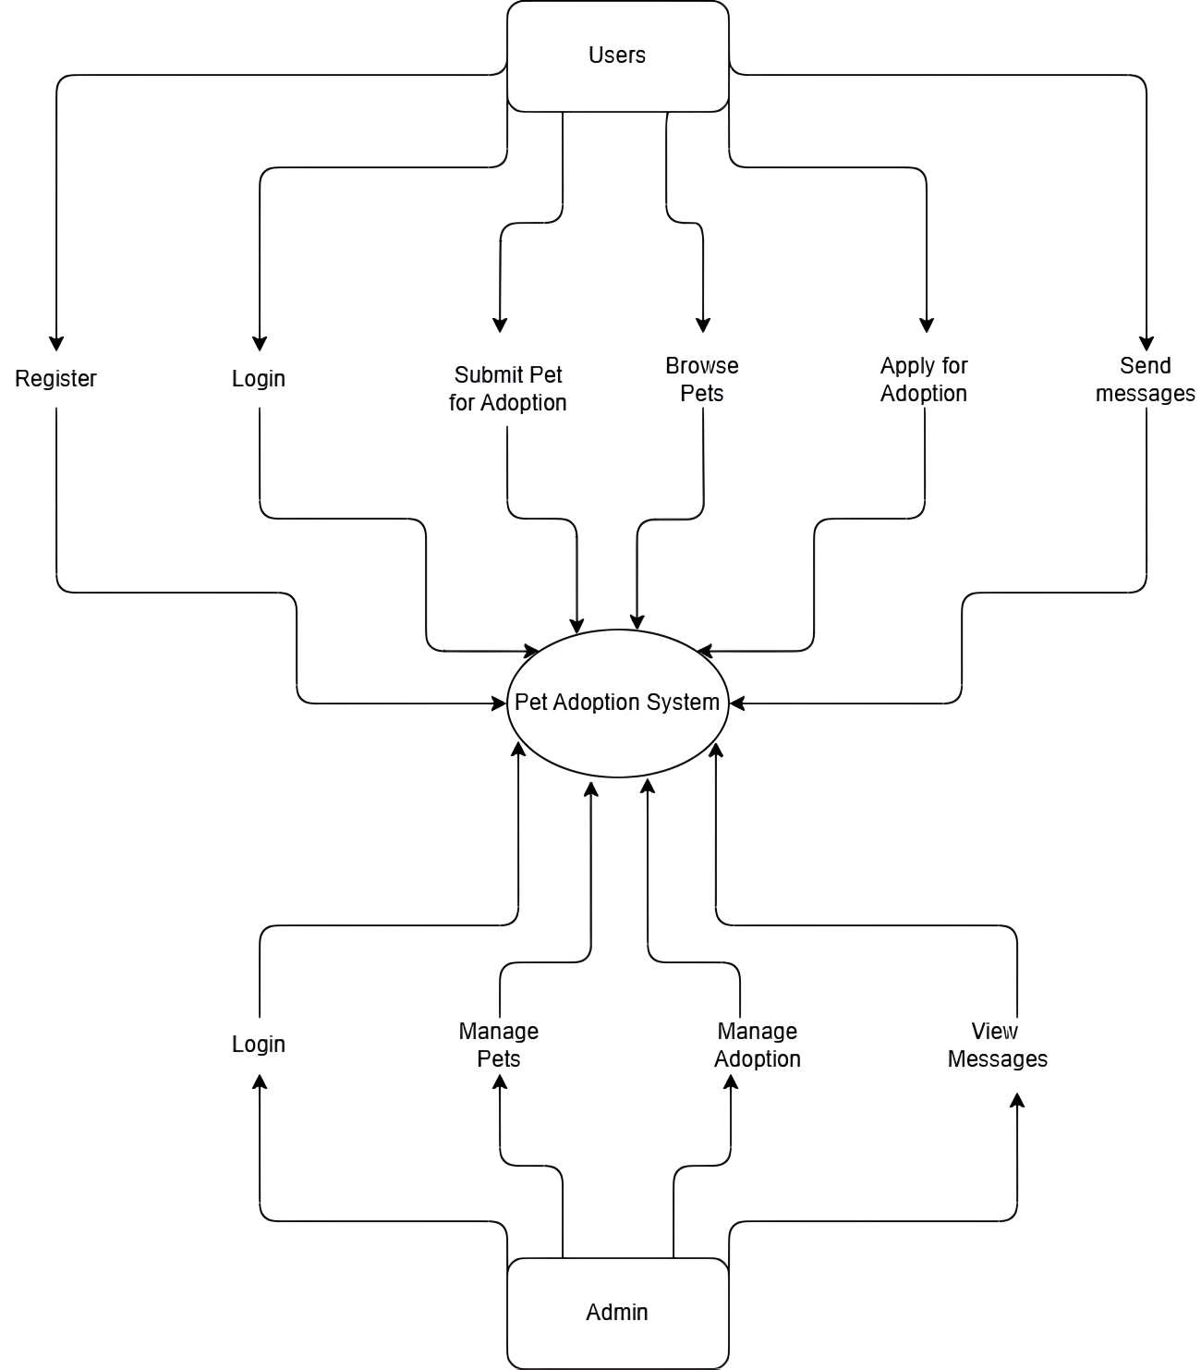

ENTITY RELATION DIAGRAM

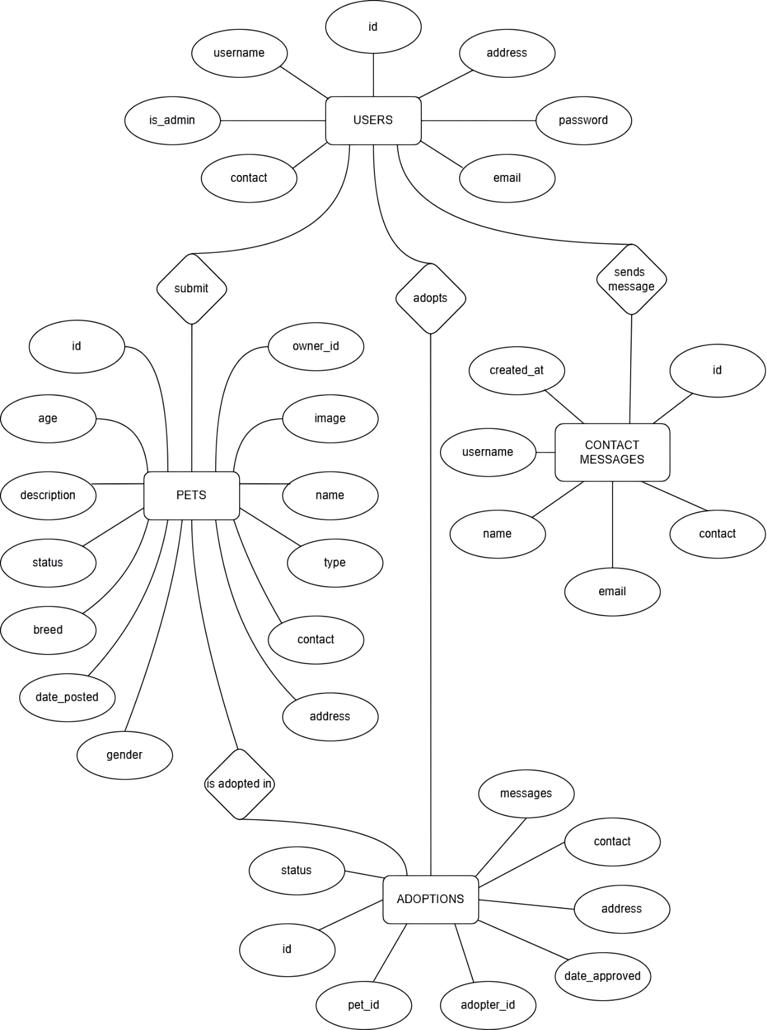
Data base table

Users table

This table stores users details
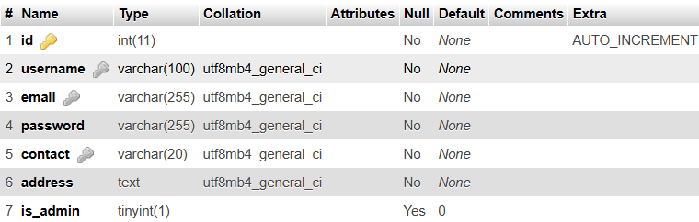

Pets table

This table stores pets details
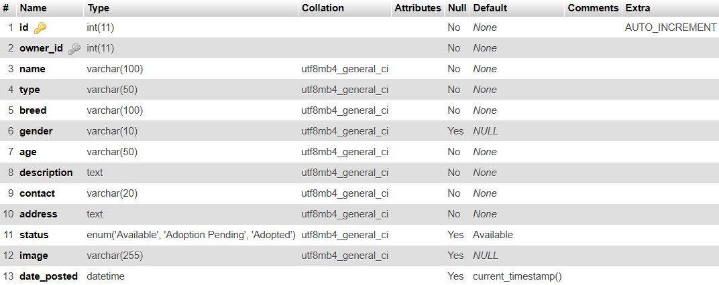

Adoption table

This table records adoption requests made by users
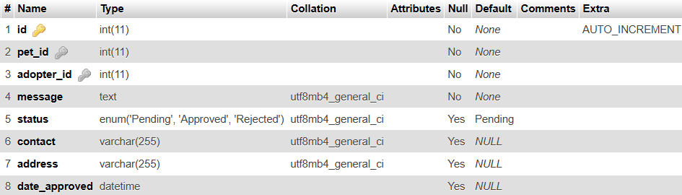

Contact messages table

This table stores messages sent to the admin
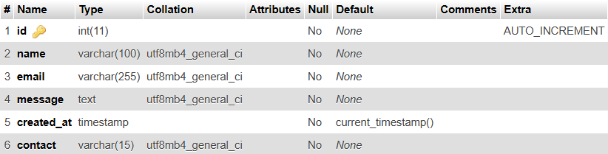

DATABASE SCHEMA

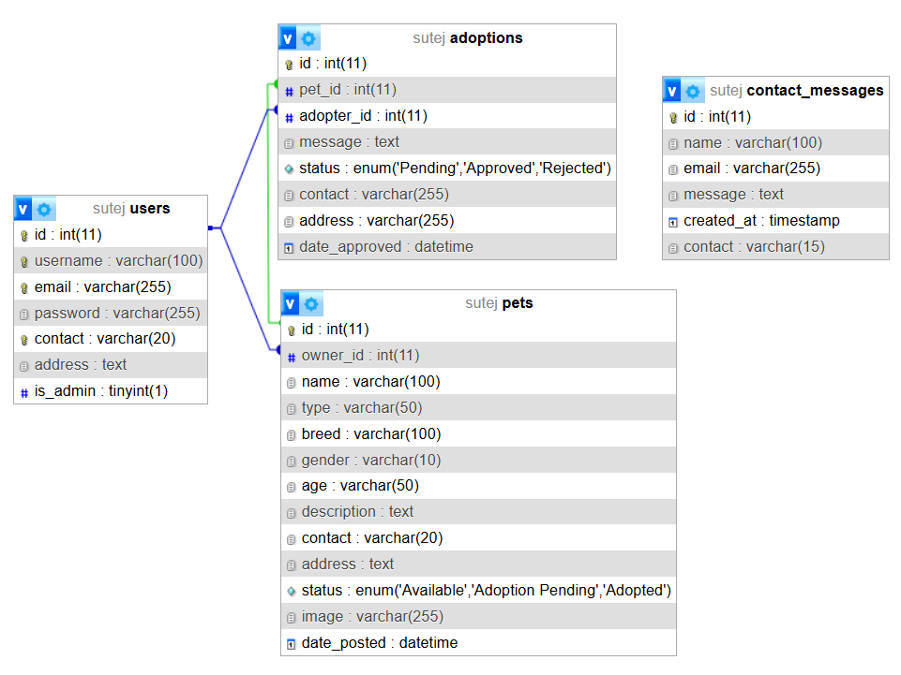

home PAGE
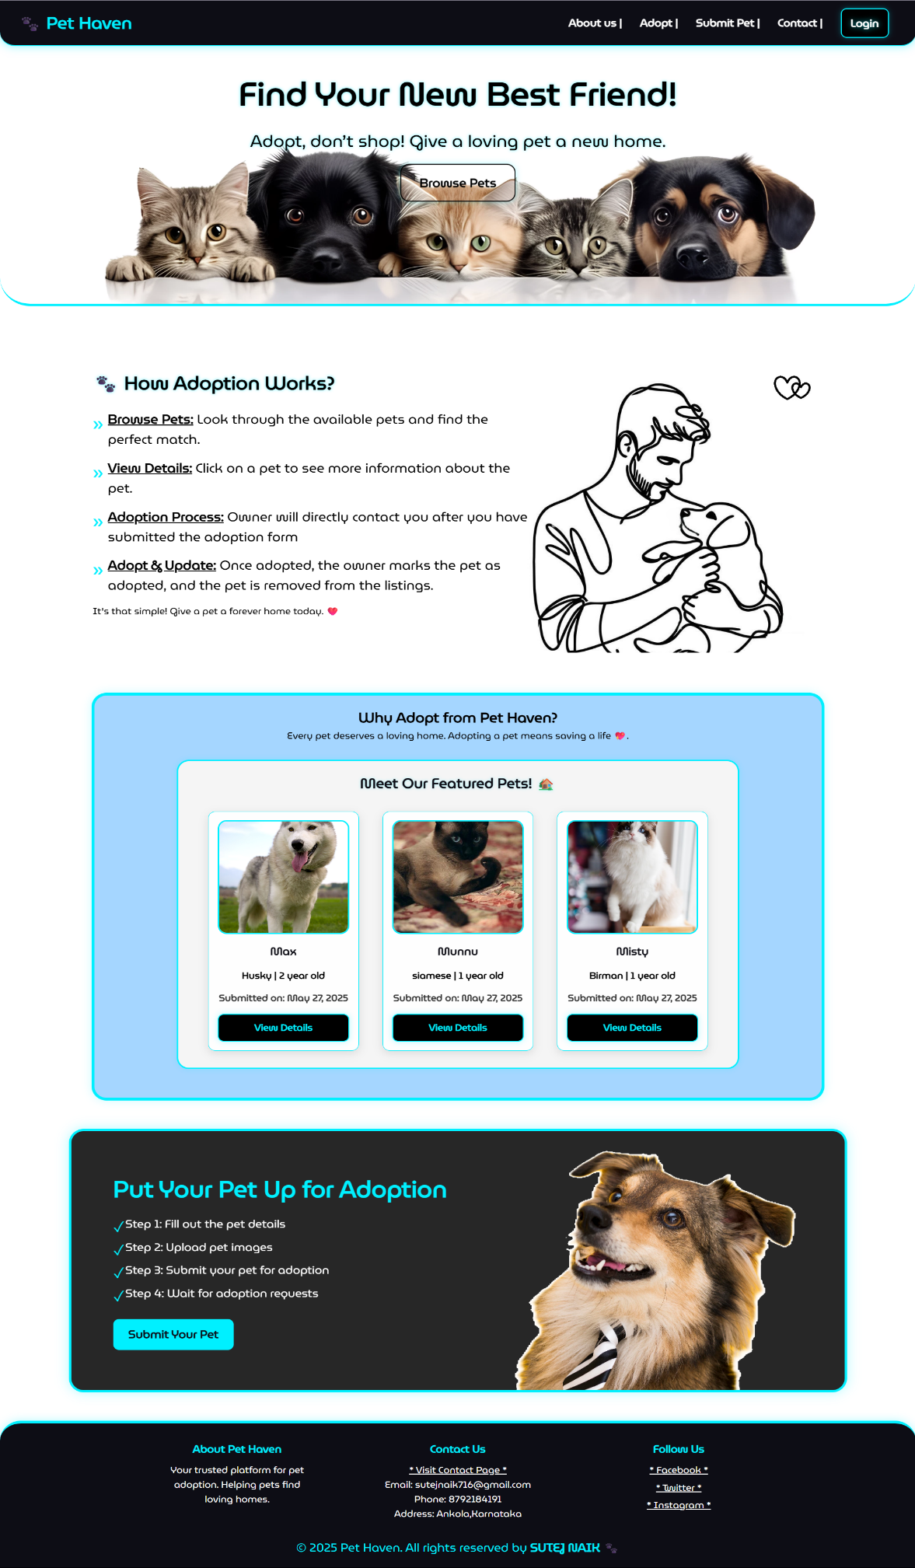
ABOUT US PAGE

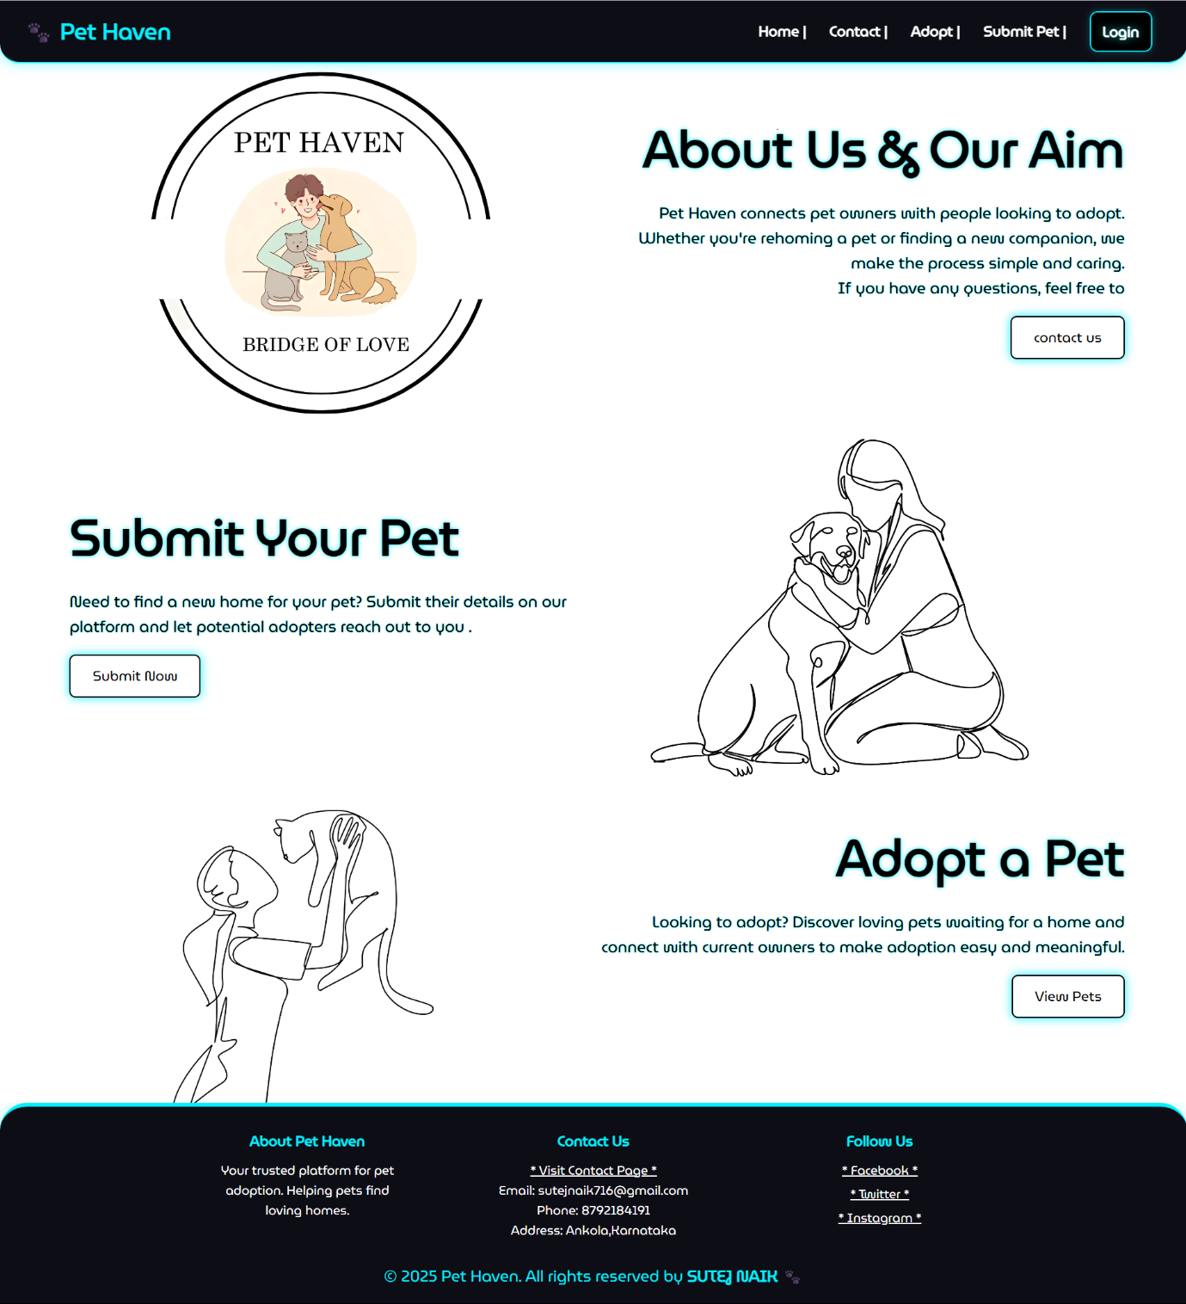

USER REGISTRATION PAGE

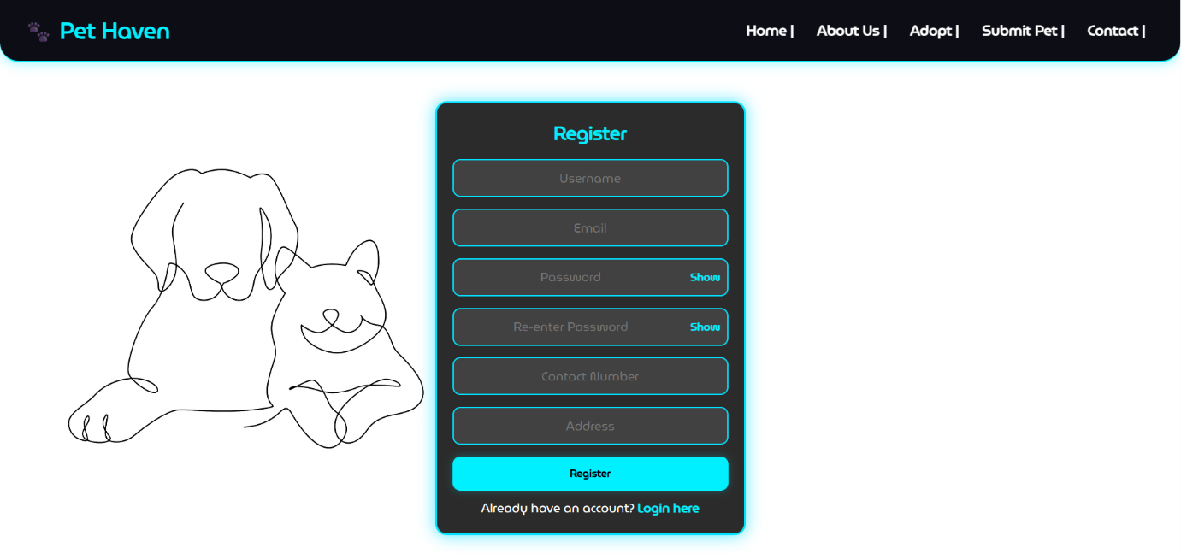

LOGIN PAGE

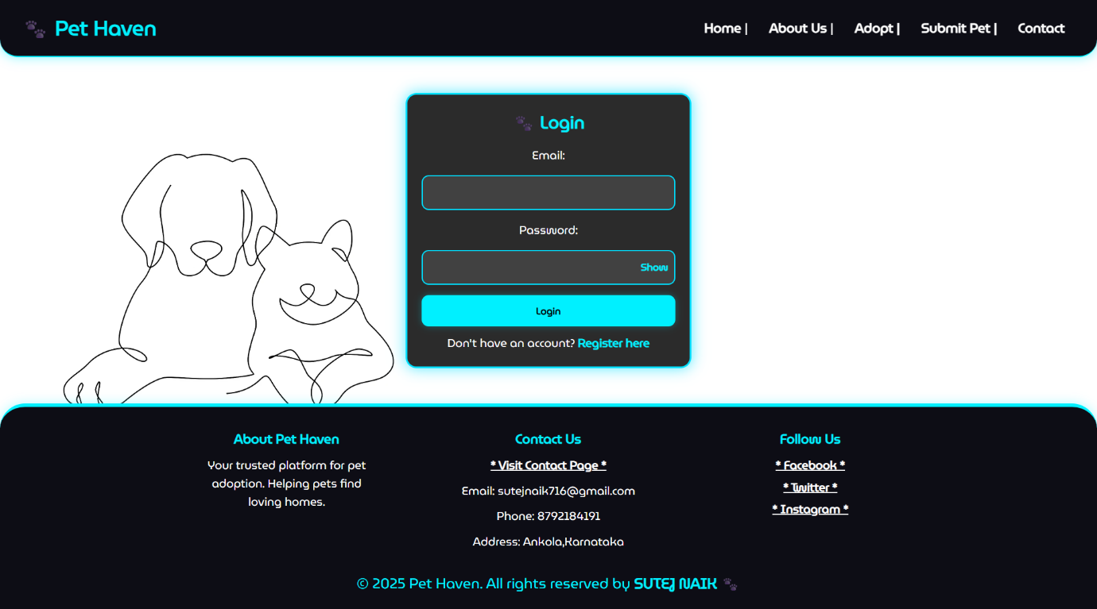
AVAILABLE PETS PAGE

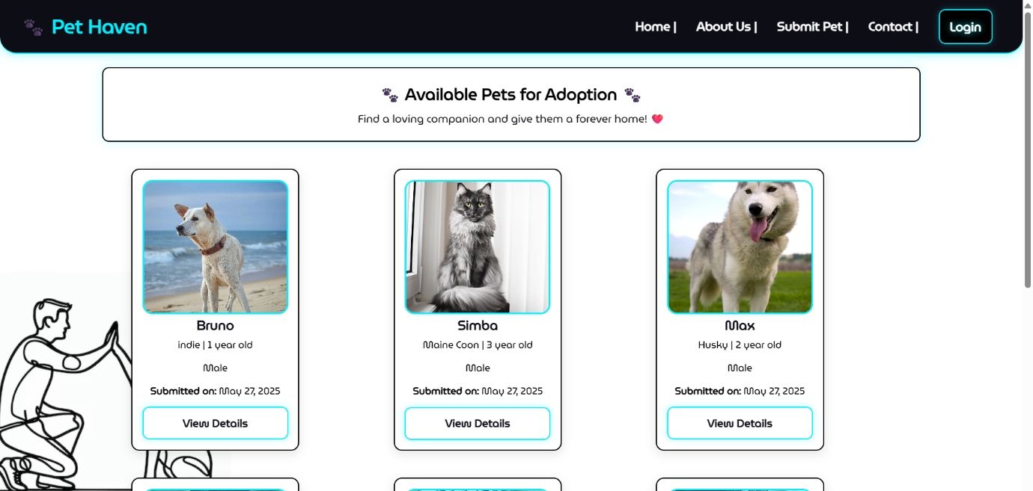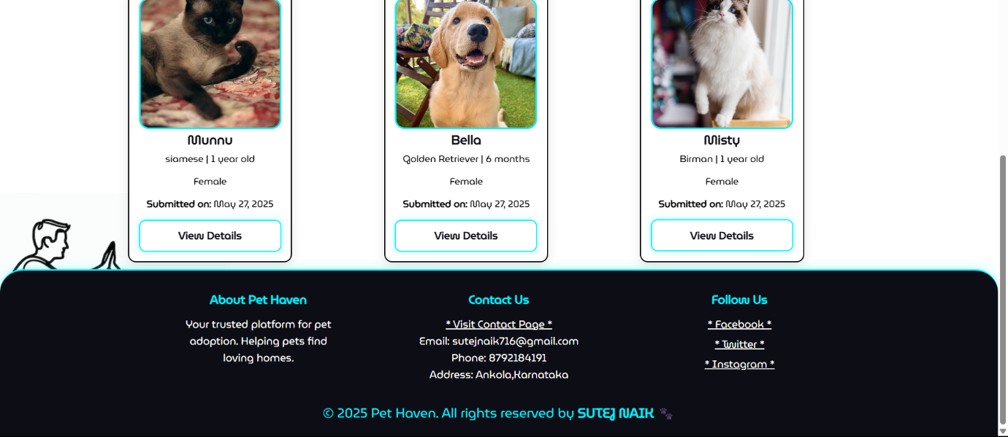

PET DETAILS PAGE

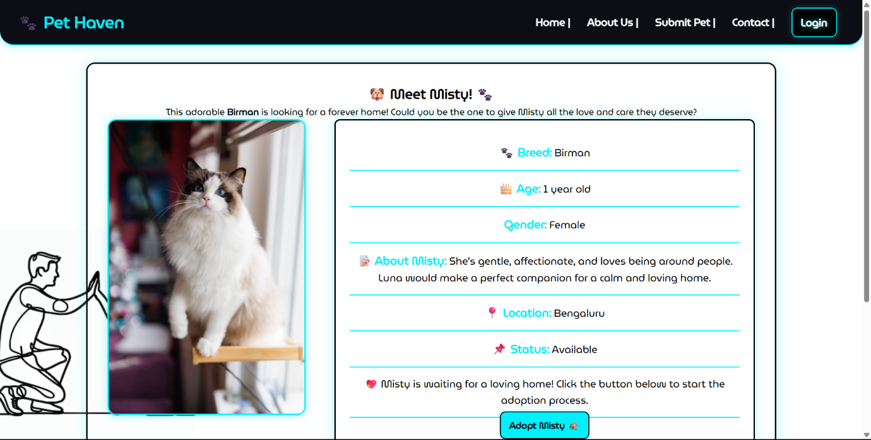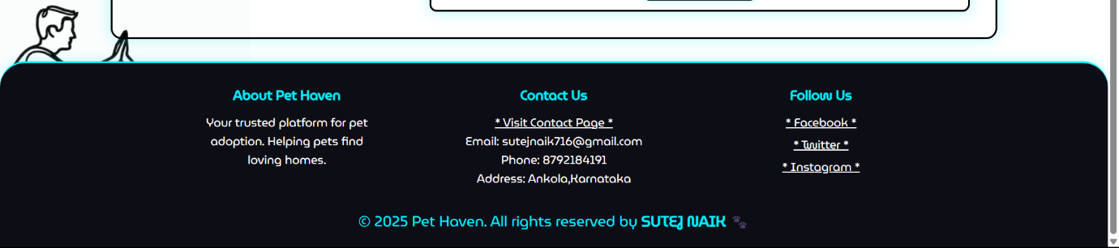

PET ADOPTION REQUEST
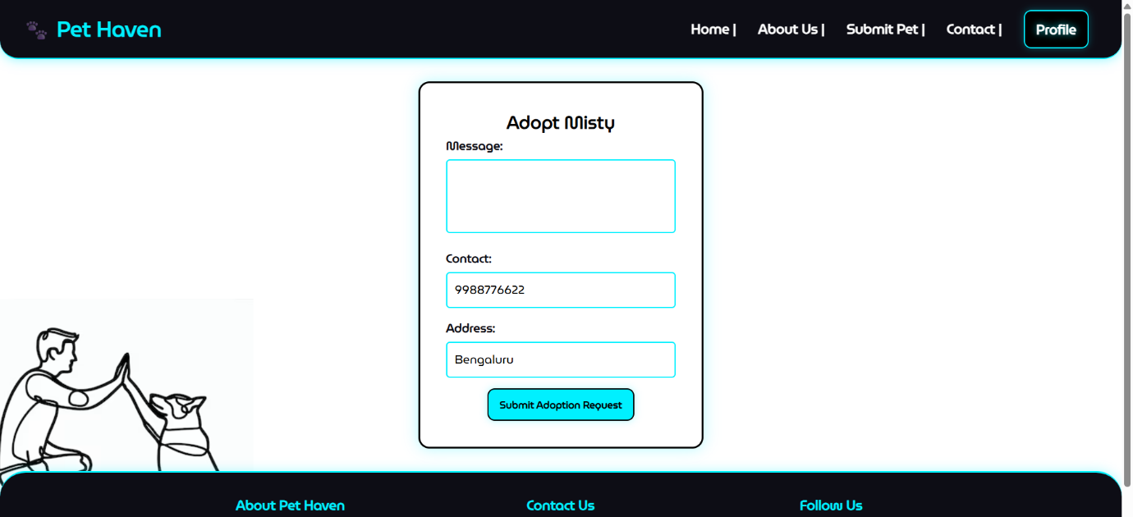
SUBMIT PET FOR ADOPTION PAGE

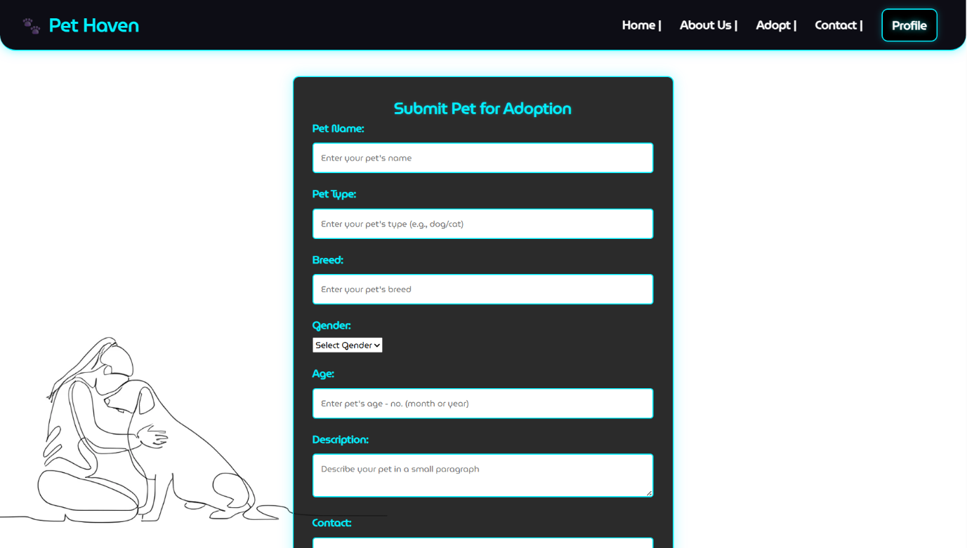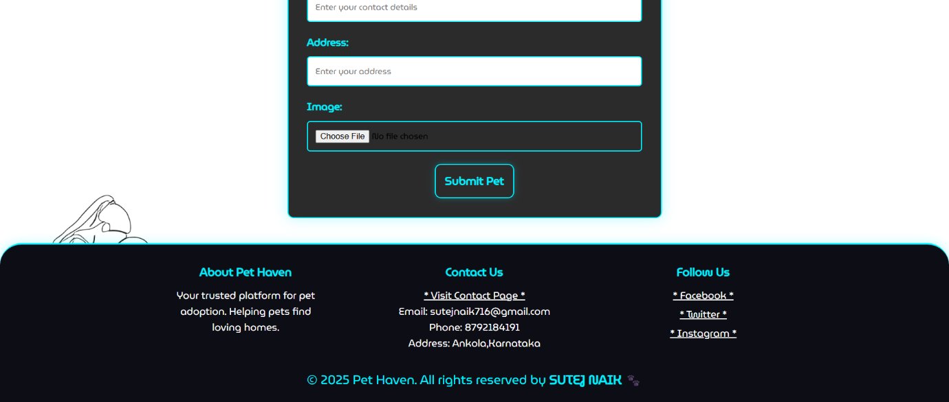

User Profile page

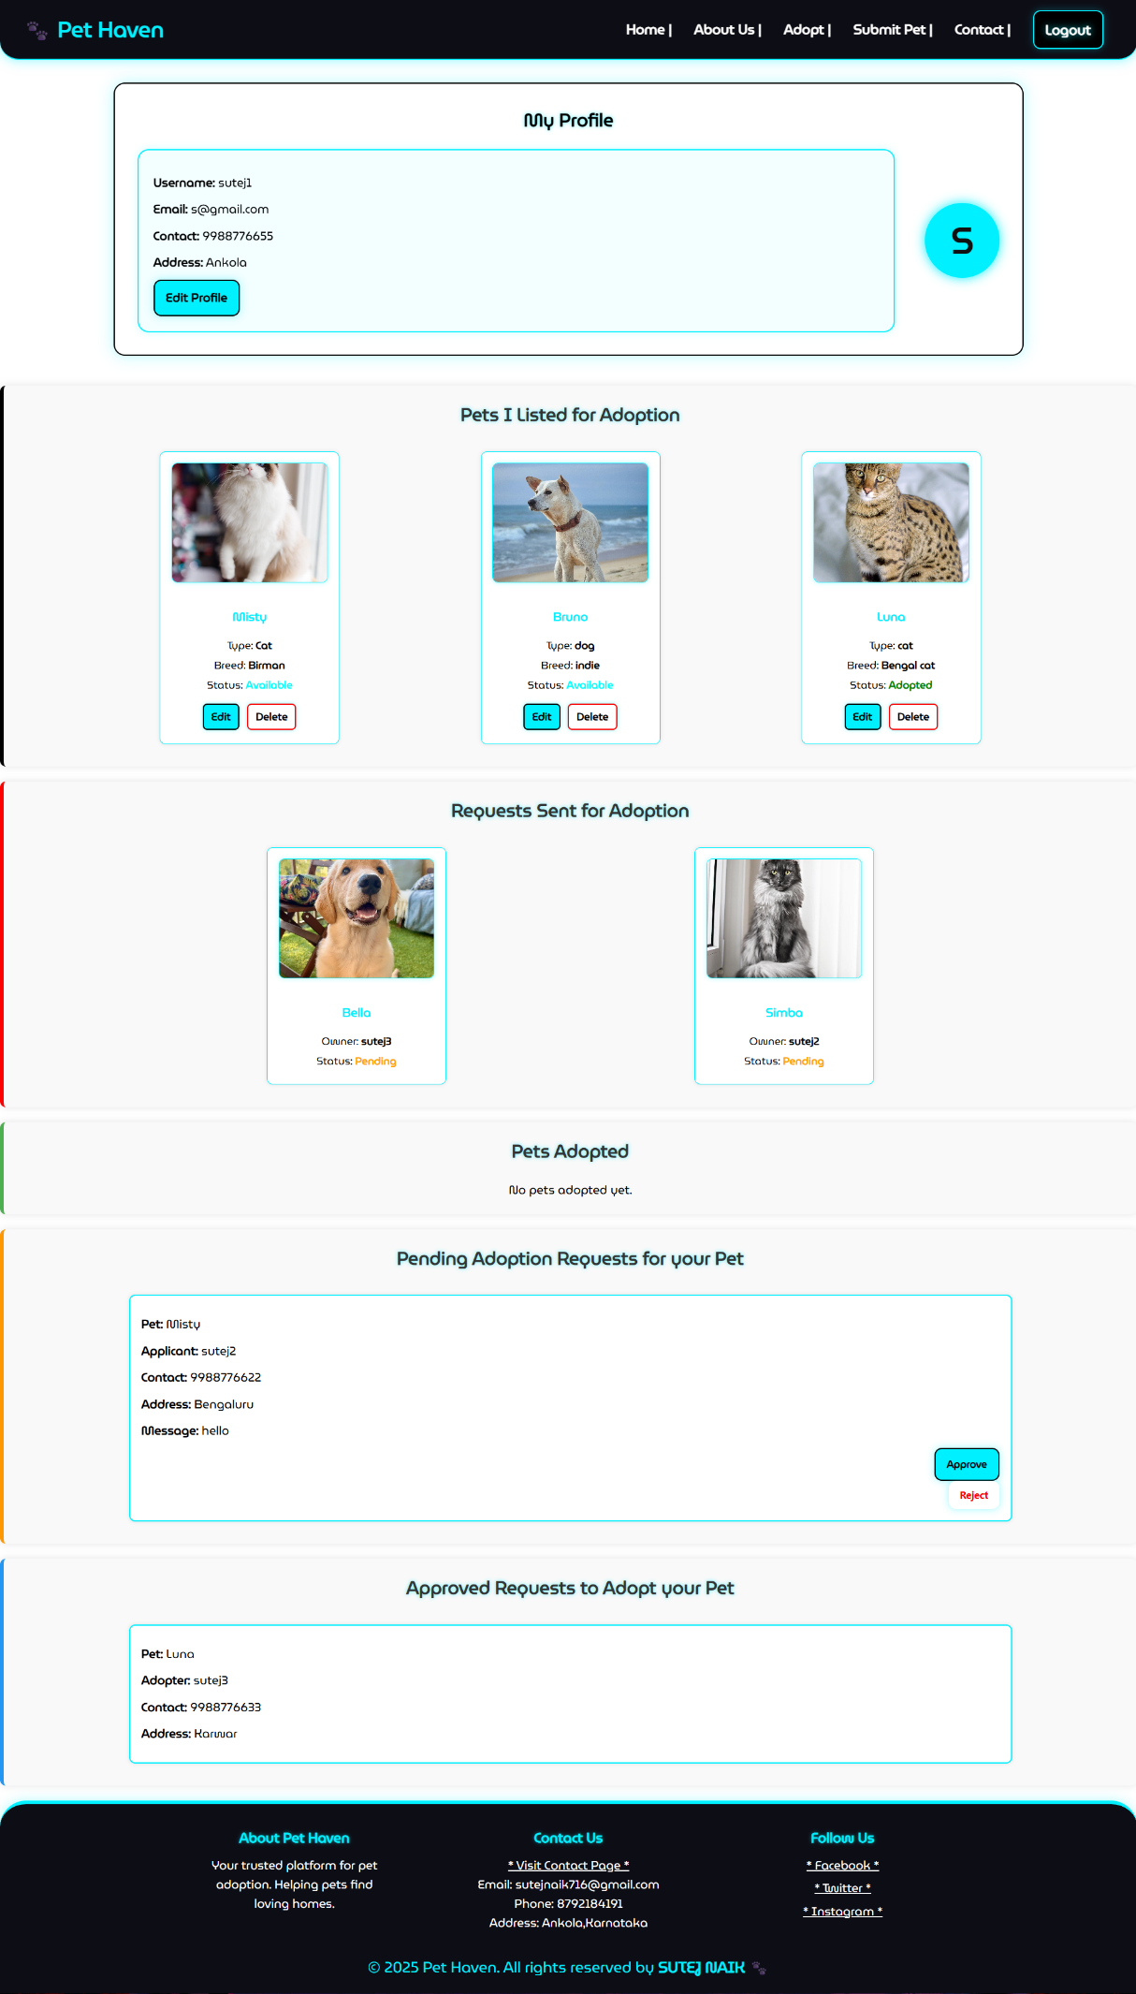
Profile edit page
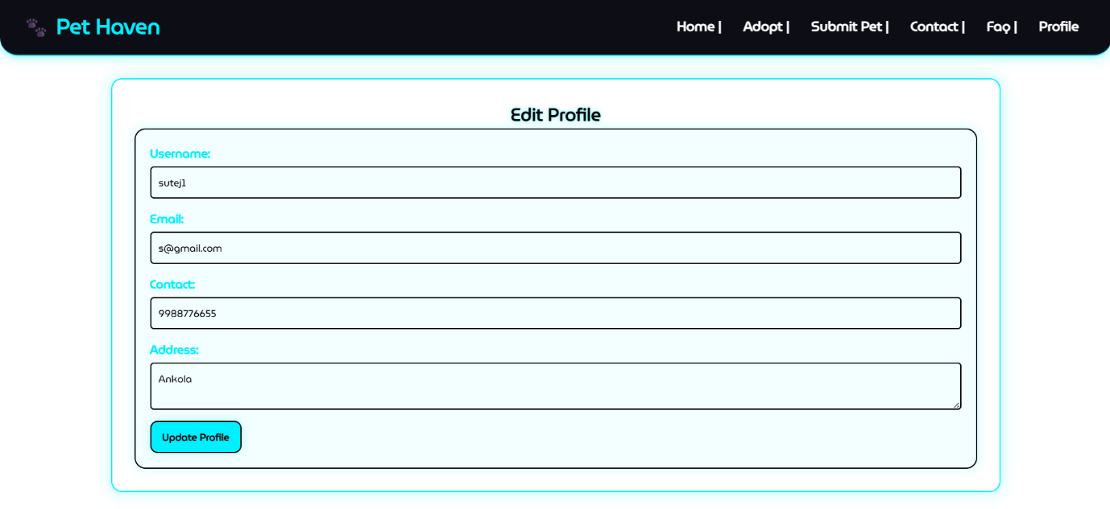

Pet edit page
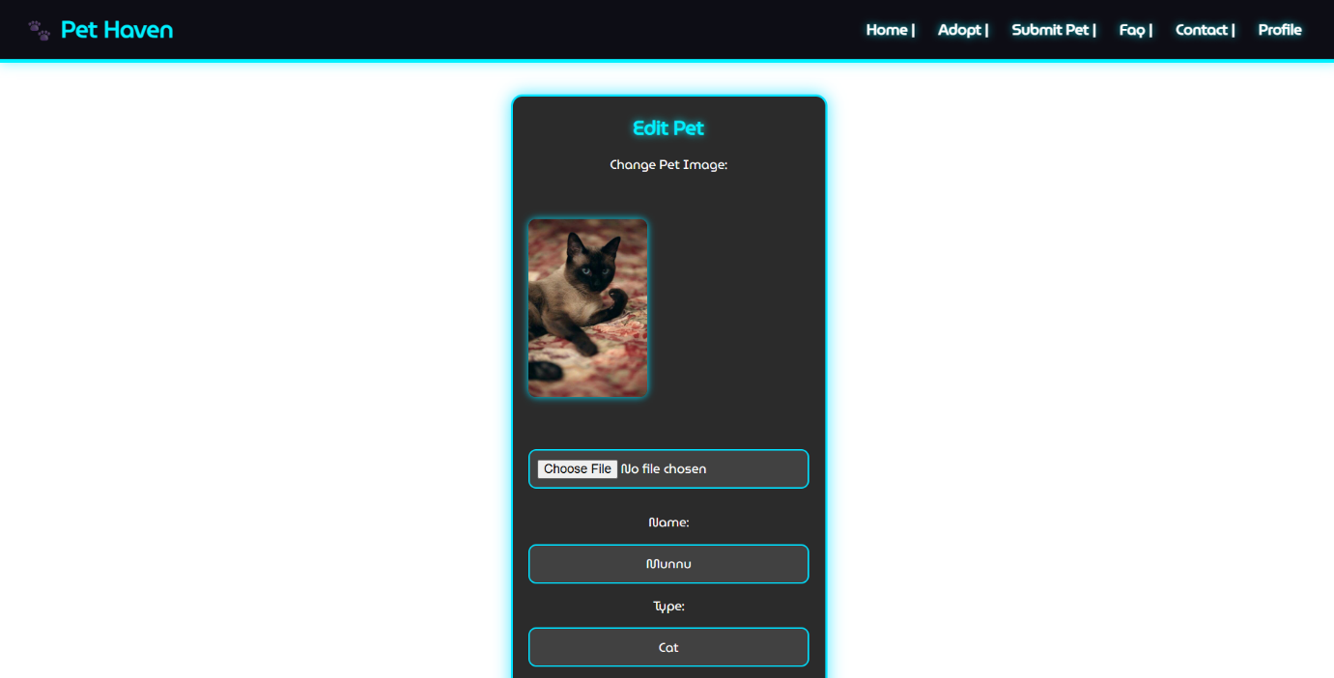
Contact us page

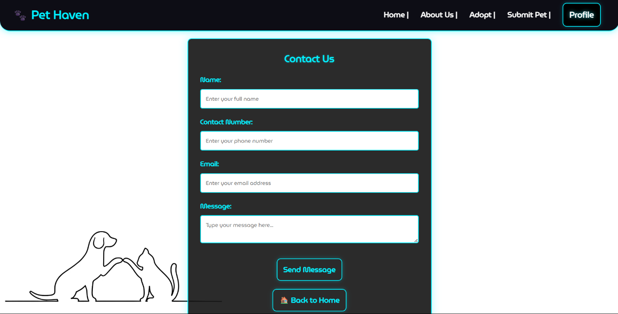

Admin dashboard

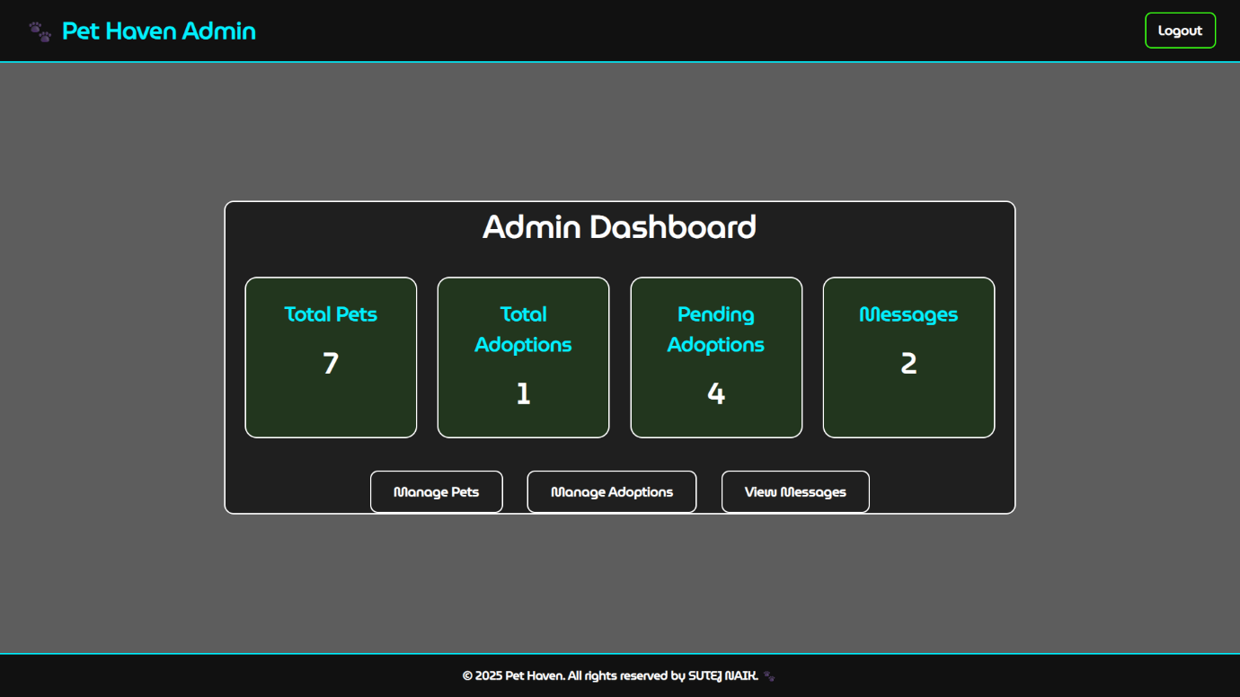
Admin - manage pet page

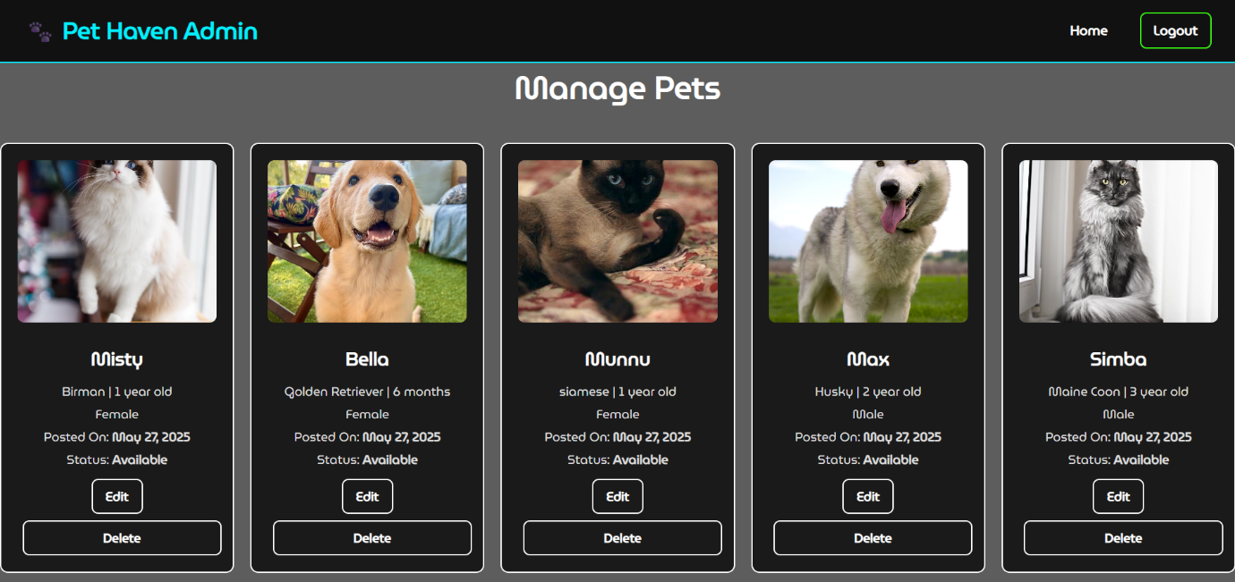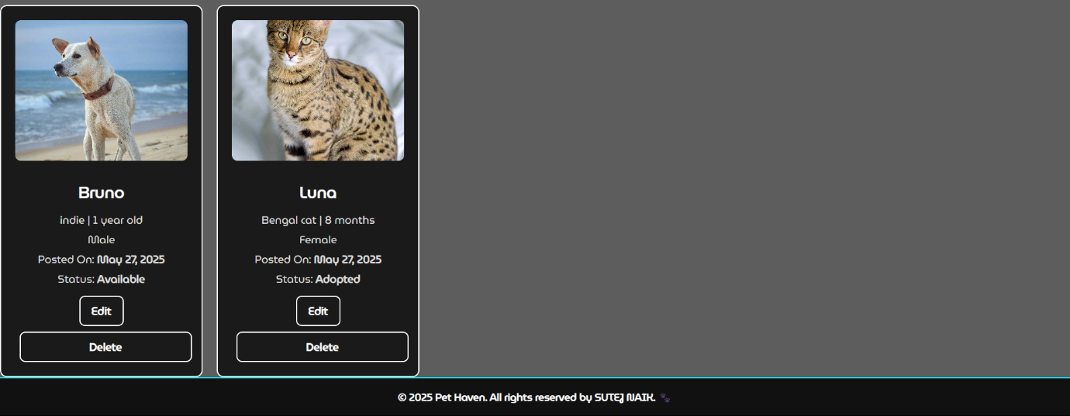

Admin – manage adoption request page

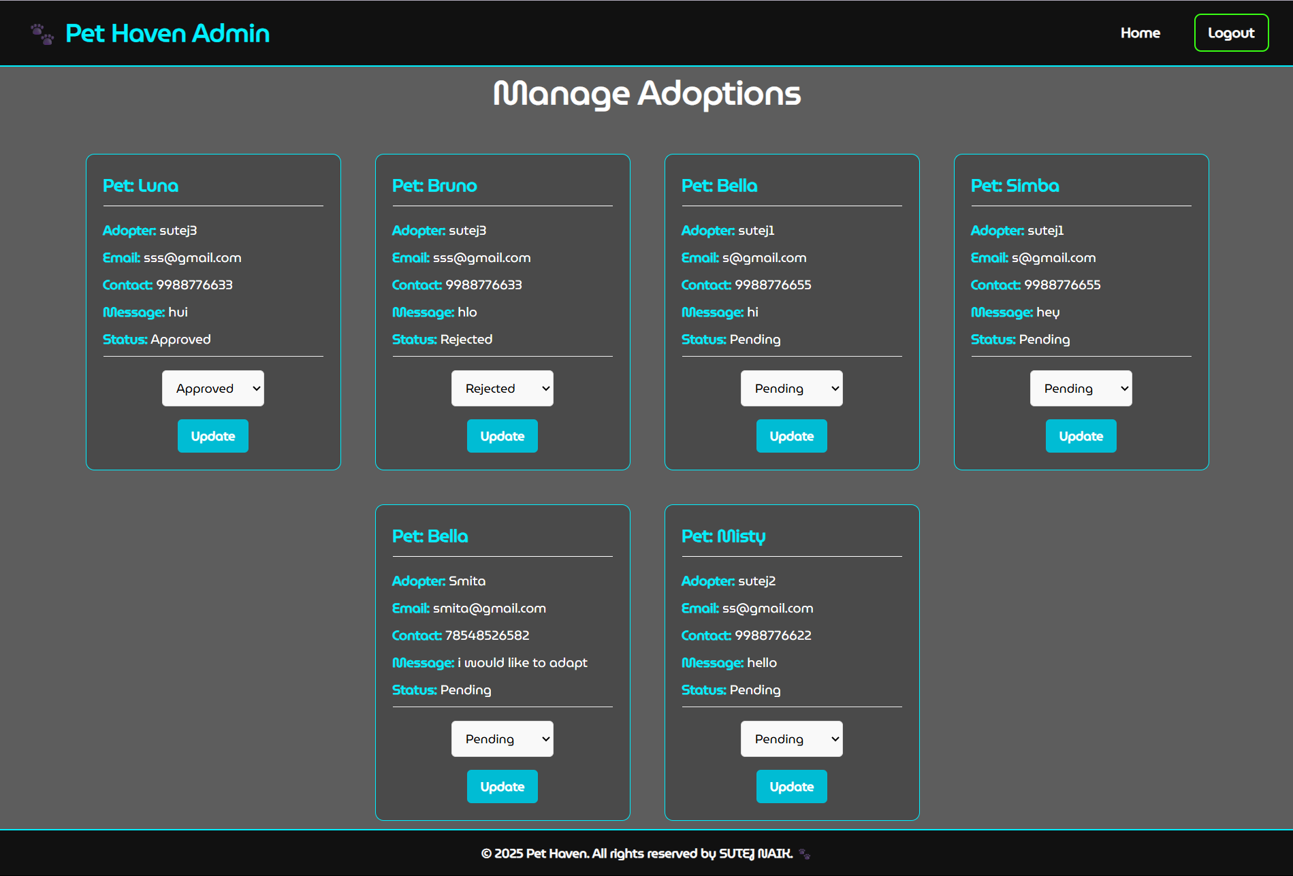

Admin – contact messages
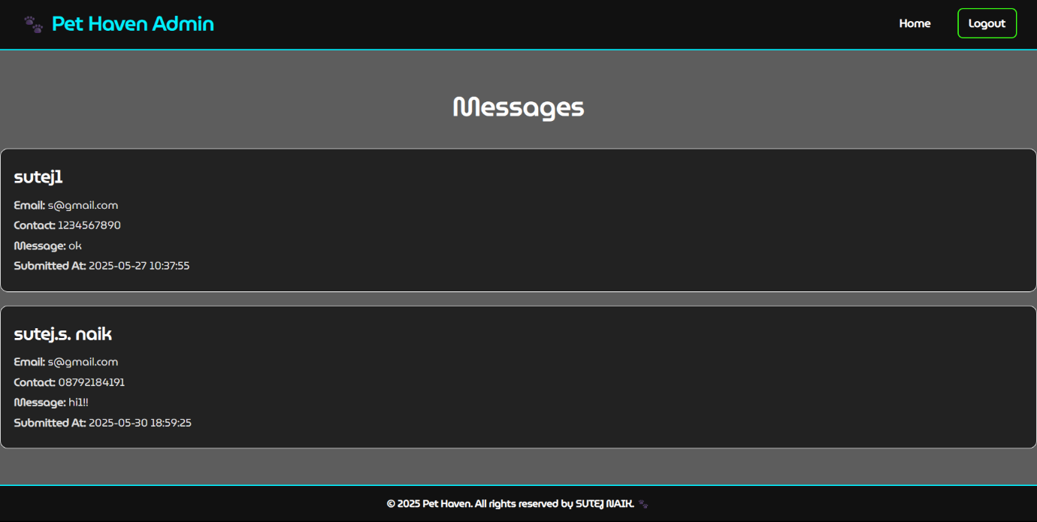
Validation

In the Pet Haven pet adoption platform, validation testing played a critical role in ensuring data integrity and user-friendly interaction. The goal was to prevent invalid data from being submitted during user registration, pet submission, and adoption request processes. This testing confirmed that all form fields across the website to behave correctly when users input invalid, incomplete, or duplicate information. Proper validation ensures that the data stored in the Pet Haven system is clean, accurate, and secure.Below are the key validation checks:
- Blank Field Check - In forms like registration, submit pet, and contact, if any required field is left empty, a message appears:“Please enter this field.”This helps users fill in all necessary details before submission.
- Data Type Validation - For fields like pet age or contact number, if alphabetic characters are entered instead of numbers, an error message such as:“Value Error”is shown to guide the user.
- Password Length Validation - During user registration, if the password entered is less than 8 characters, the system prompts:“Please enter at least 8 characters.”to ensure account security.
- Empty Field Prompt - If users try to skip a required field, they are alerted with:“Enter this field.”This ensures no crucial information is missed, such as pet name or adopter details.
- Duplicate Entry Check - When a user tries to register with an email, phone number, or username that already exists in the system, the website displays:“Already exists.”to avoid data duplication and maintain unique records.
These validation checks were applied throughout the Pet Haven website to ensure a smooth, error-free experience for both pet owners and adopters, and to maintain the accuracy and quality of data stored in the system.s
Testing

Testing is an essential phase in the development of Pet Haven, aimed at identifying errors and ensuring the system functions as intended. It serves as a crucial quality assurance measure to validate that the application meets the defined requirements and behaves correctly under various conditions.
During testing, the website was executed using a set of predefined test cases. Each feature and module was thoroughly evaluated by observing its output and functionality. This process helped confirm that the website operates efficiently and meets user expectations.

SYSTEM TESTING
The goal of system testing was to identify and eliminate any functional or integration issues across the entire Pet Haven platform. Various modules like user registration, login, pet submission, pet listings, adoption requests, and admin controls were tested with real and edge-case data.
The project was subjected to multiple rounds of input testing to ensure that:
- Pets could be submitted and displayed correctly.
- Users could register, log in, and perform authorized actions.
- Adoption requests were sent, stored, and updated properly.
- Admin features worked securely and without error.

1. UNIT TESTING
Unit testing was performed on individual modules and scripts within the Pet Haven project. This included:
- Validating user input forms (e.g., registration, submit pet, contact forms)
- Verifying PHP scripts for login, logout, and session management
- Testing backend database operations such as insert, update, and delete for users, pets, and adoptions
Each script was tested independently to ensure it functioned correctly before being integrated into the full system.

2. INTEGRATION TESTING
Integration testing was conducted to verify the interaction between various modules. It ensured that when one component called another, data passed correctly, and no conflicts occurred.
Examples of integrated modules tested:
- After logging in, a user can submit a pet → Pet is displayed on pets.php → Pet details open correctly from listing.
- When a user applies for adoption → Owner sees the request in their profile → Owner can approve or reject → Status updates and pet is removed from listing if adopted.
- Admin panel integrates pet and adoption tables → Admin can manage and update data with proper access.
Through integration testing, the entire Pet Haven workflow—from user registration to pet adoption approval—was tested for smooth operation.
Limitations

- No OTP or Email Verification - User registration and login do not include email verification or OTP confirmation, which can lead to fake accounts being created.

- Not Mobile Responsive - The website is designed for desktops only and may not display properly on tablets or smartphones.

- No Email Notifications - When an adoption is approved or a pet is submitted, no email notifications are sent to the users or admins

- No Real-Time Updates - Changes like adoption status updates require page reload; there is no use real-time notifications.

Future scope of the project

- Real-time Notifications – Adding email or real-time notifications for adoption updates and other notifications.

- Pet Health Records – Allowing users to upload medical history and vaccination records of pets.

- Chat System – Integrating a direct messaging system between adopters and pet owners.

- Mobile App Integration – Expanding the project into an Android/iOS app for better accessibility.

Conclusion

The Pet Haven website was developed as a user-friendly platform to facilitate pet adoption and help connect pet owners with potential adopters. The primary goal of the project was to simplify the adoption process while offering a clean, structured interface that is easy to use even for non-technical users.
This project successfully demonstrates the use of basic web development technologies including HTML, CSS, PHP, MySQL, and basic JavaScript for form validation. It incorporates essential features such as user registration, pet submission, adoption application, and admin management, meeting the basic needs of a pet adoption system.
While the system has some limitations, such as the absence of email notifications, it effectively showcases the foundational components of a working web-based application.
Overall, the development of Pet Haven enhanced the understanding of practical web development, backend integration, and database handling. It also demonstrated how software can be used to solve real-life problems and contribute to a good cause—helping animals find loving homes.

Bibliography

- W3Schools Online Web Tutorials
HTML, CSS, PHP, MySQL Basics and Examples
https://www.w3schools.com

- PHP Manual – Official Documentation
Reference for PHP syntax, functions, and security practices
https://www.php.net/manual/en/

- MySQL Documentation – MySQL 8.0 Reference Manual
Helped with writing SQL queries and understanding database structure
https://dev.mysql.com/doc/

- JavaScript.info
Helped understand JavaScript syntax, DOM manipulation, and basic interactivity
https://javascript.info

